Linguistic and Grammatical Rules for Aspect Extraction

Noun linked to adjective:

* Noun chunk + linking verb + adjective

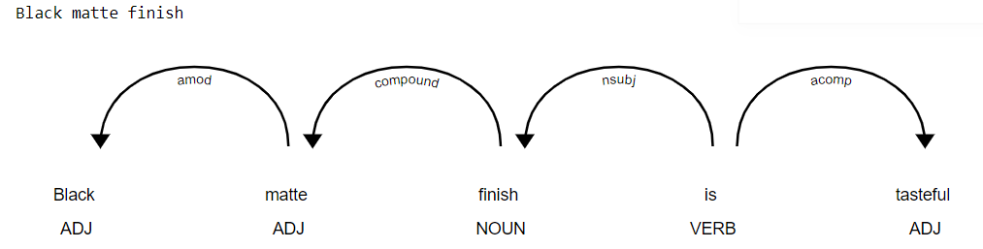

Noun linked to other noun

* Noun chunk + linking verb + noun chunk
* Includes a skips list so that we do not repeat noun chunks

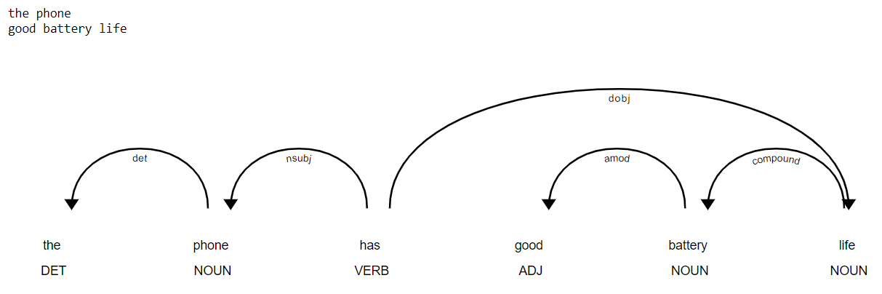

Handling compound aspects

* Compound versions of the above
* Requires a recursive function that takes the first child, identifies any children, and recursively extracts children of children
  + If any of the children meet our criteria as well then they are extracted

